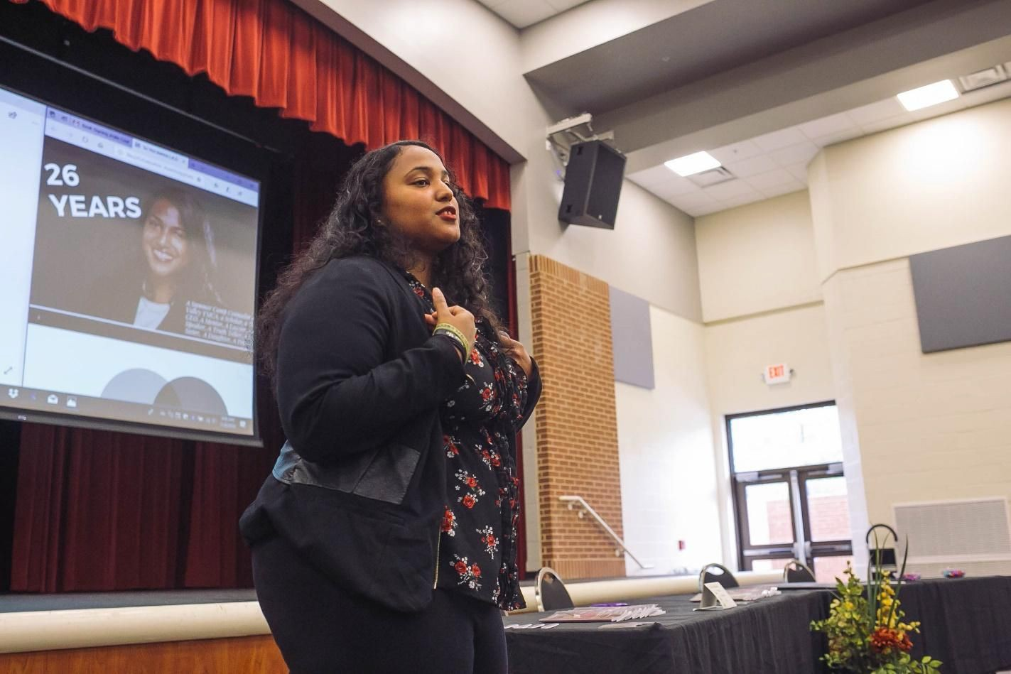

Neena The L.A.S.T. Brand Team

Speaker Agreement
─
Neena R, Speer, Esq.
Author of “Dear Future Lawyer: An Intimate Survival Guide for the Female Minority Law Student”

Welcome
Hey [ORGANIZATION],

My team and I have discussed an upcoming event with your organization and are excited to bring a tremendous amount of value to the attendees. As you already know, Neena has had the opportunity to talk in front of many large audiences, but she is really excited about this group. It looks like you've done a great job setting up this event and we are looking forward to being a part of its success.

Regards,
Neena the L.A.S.T. Brand Team neenathelastbrand@gmail.com

See YOU In Action
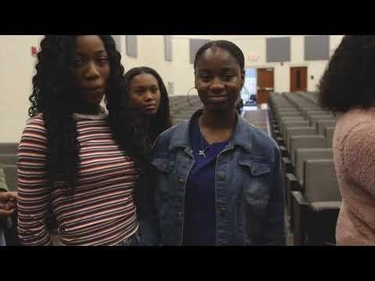

About Neena Speer
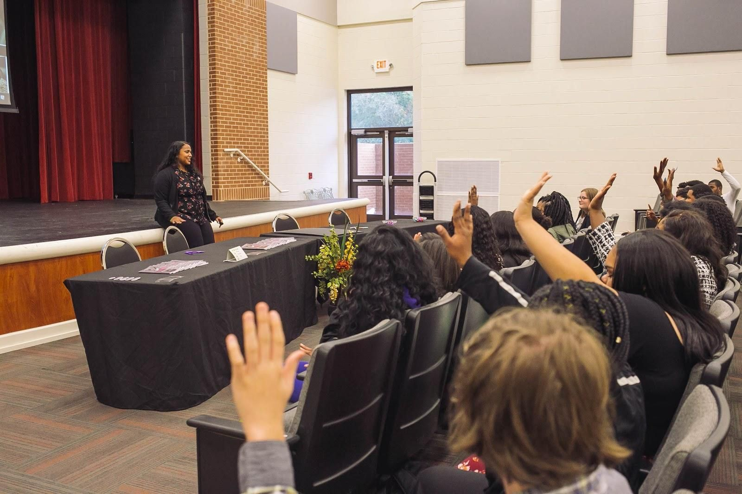

Use a Photo of You Speaking ^

Your Back Story Bio and Who You Are

Optional Highlights:
- Unique Fact About You or Your Journey #1
- Unique Accomplishment About You or Your Journey #1
- Unique Pain Point About You or Your Journey #1
- Unique Early or Out of The Box Milestone About You or Your Journey #1

Your Longer Bio

About Dear Future Lawyer by Neena Speer
This book will :
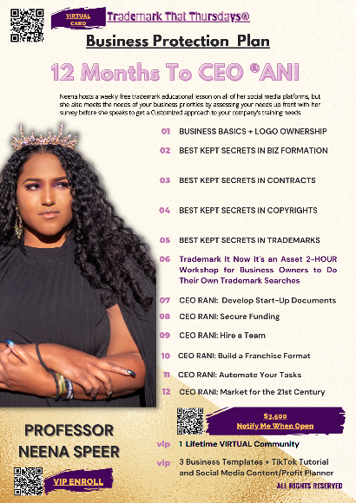
- Value Offered Point #1
- Value Offered Point #2
- Value Offered Point #3
- Value Offered Point #4
- Value Offered Point #5
- BONUS Value Offered IN PARAGRAPH

ASSET NAME Your Product Asset That You Sell full description

Speaker Agreement for ORGANIZATION]
This AGREEMENT is made between [ORGANIZATION], [Company Address] and YOUR COMPANY NAME, (“Speaker”), 1YOUR MAILING ADDRESS on
DATE.

The speaker, to the best of his ability, shall present for the following: (please fill in below)

Session Date and Time
Name and Address of Event Venue Anticipated Number of Attendees
Main Contact at Event Full Name
Title Phone Email

Equipment and Room Setup Specifications

Projector and replacement bulb Speaker Podium or Table Projector Screen Music Adapter for Projector
Bottle of Water
Slides Remote ("Clicker")
Audio System (PA)
Chairs for Attendees
Lavalier (preferred) or Handheld Microphone
Table and Chair for Book Signing

Please initial which equipment will be provided if there is an individual session.

Speaker's Fee
YOUR NAME has multiple speaking engagements booked and is typically scheduled 3 months in advance, so availability is limited.

Session 1 $####.00
€
20-45min presentation tailored to 0-100 attendees. An additional 15 minutes of Q&A is included.

TOTAL: [$#####.00]

Compensation
As consideration for the services to be rendered by Speaker under this Agreement,
ORGANIZATIOM shall provide the Speaker:

- Complimentary Event registration.
- Hotel/ Lodging accommodations (if applicable) for your Speaking TITLE Event. 1-2 nights (only when arranged by ORGANIZATION). In the event, the Speaker must stay at the hotel/lodging for additional nights due to travel delays through no fault of Speaker, ORGANIZATION shall pay all hotel/lodging accommodation costs for such additional night(s).
- Travel Expenses (if applicable). ORGANIZATION shall arrange and pre-pay for airline tickets from the Speaker's airport, YOUR AIRPORT CODE, to the venue's airport for the Speaker; ground transportation for the Speaker and assistant between the venue's airport and the Speaker's hotel; meals for Speaker for which receipts are provided; and all other reasonable, documented expenses necessary to the Speaker's conduct of the presentation during the time period of the event.

FSU BLSA AT FSU shall have Neena’s Speaker's Fee of [PricingTable1. Total] on deadline established one month minimum before the event.
Payment will be completed at the end of this document.

The Speaker shall submit receipts and an itemized invoice for expenses to FSU BLSA within 7 (seven) days of the event's end date. ORGANIZATION shall reimburse the Speaker with 30 (thirty) days of receiving receipts and invoice.

Terms of Agreement
This Agreement shall continue in effect until:

  - Canceled by either party as set forth in this Agreement; or
  - Completion of the session presentation(s) by Speaker provided, however, that in the event of cancellation pursuant to this Agreement, or upon death, disability, or other incapacity resulting in the inability of Speaker to present the session(s) required (“cancellation”), this Agreement may be terminated and all consideration due shall cease as of the date of cancellation.

Approved by: Agreed to by:
YOUR COMPANY NAME [Organization],

YOUR NAME
signature and date

TITLE [/s/ Your Name], DATE

Speaker and Session Promotion
Speaker information will appear as written below in all conference marketing materials and the on-site conference brochure:

Neena R. Speer, Esq., Author of Dear Future Lawyer Neena the L.A.S.T. Brand, Birmingham, AL

Optional: Speaker may elect to have additional contact information provided in the conference marketing materials and/or on-site conference brochure:
Instagram: @DearFutureLawyer https://www.facebook.com/dearfuturelawyer/ neenathelastbrand@gmail.com neenathelastbrand.com

€ Yes, the information above can be provided in the conference marketing materials and/or on-site conference brochure.
No, the information above can not be provided in the conference marketing materials and/or on-site conference brochure.
€

License for Content (archiving/capture)
Speaker grants to [Company] a non-exclusive license to use Speaker’s presentation and handout materials (collectively “Speaker Property”) in any manner [Company] deems appropriate including, but not limited to, the reproduction, distribution, creation of derivative works, and display on the internet of Speaker Property, with [Company] retaining the proceeds derived from such distribution and use of Speaker Property.
Speaker also agrees to work directly with the company performing these services for [Company] and follow all deadlines to provide presentations slides and potential handouts that may be associated for content archiving.
Please indicate your choice below:
€ Yes, agree to the content archiving/capture of my session(s).
€ No, I do not agree to the content archiving/capture of my session(s).

Invoice
From: To:
Neena the L.A.S.T. Brand [FSU BLSA]

Payment amount:
Speaker Fee ($500.00)
Travel Expenses to include Flight, Meals and Lodging
[Unpaid]
FSU BLSA shall pay by time of booking unless specifically agreed upon by Neena the L.A.S.T Brand,LLC

